**SYEDA FATIMA SHAH**

**24th March 2023**

***Task # 7:***

**Practice following DML commands in SSMS:**

**1 - INSERT:**

**• Identity**

**• Creating a table from another table**

**• Inserting rows from one table to another**

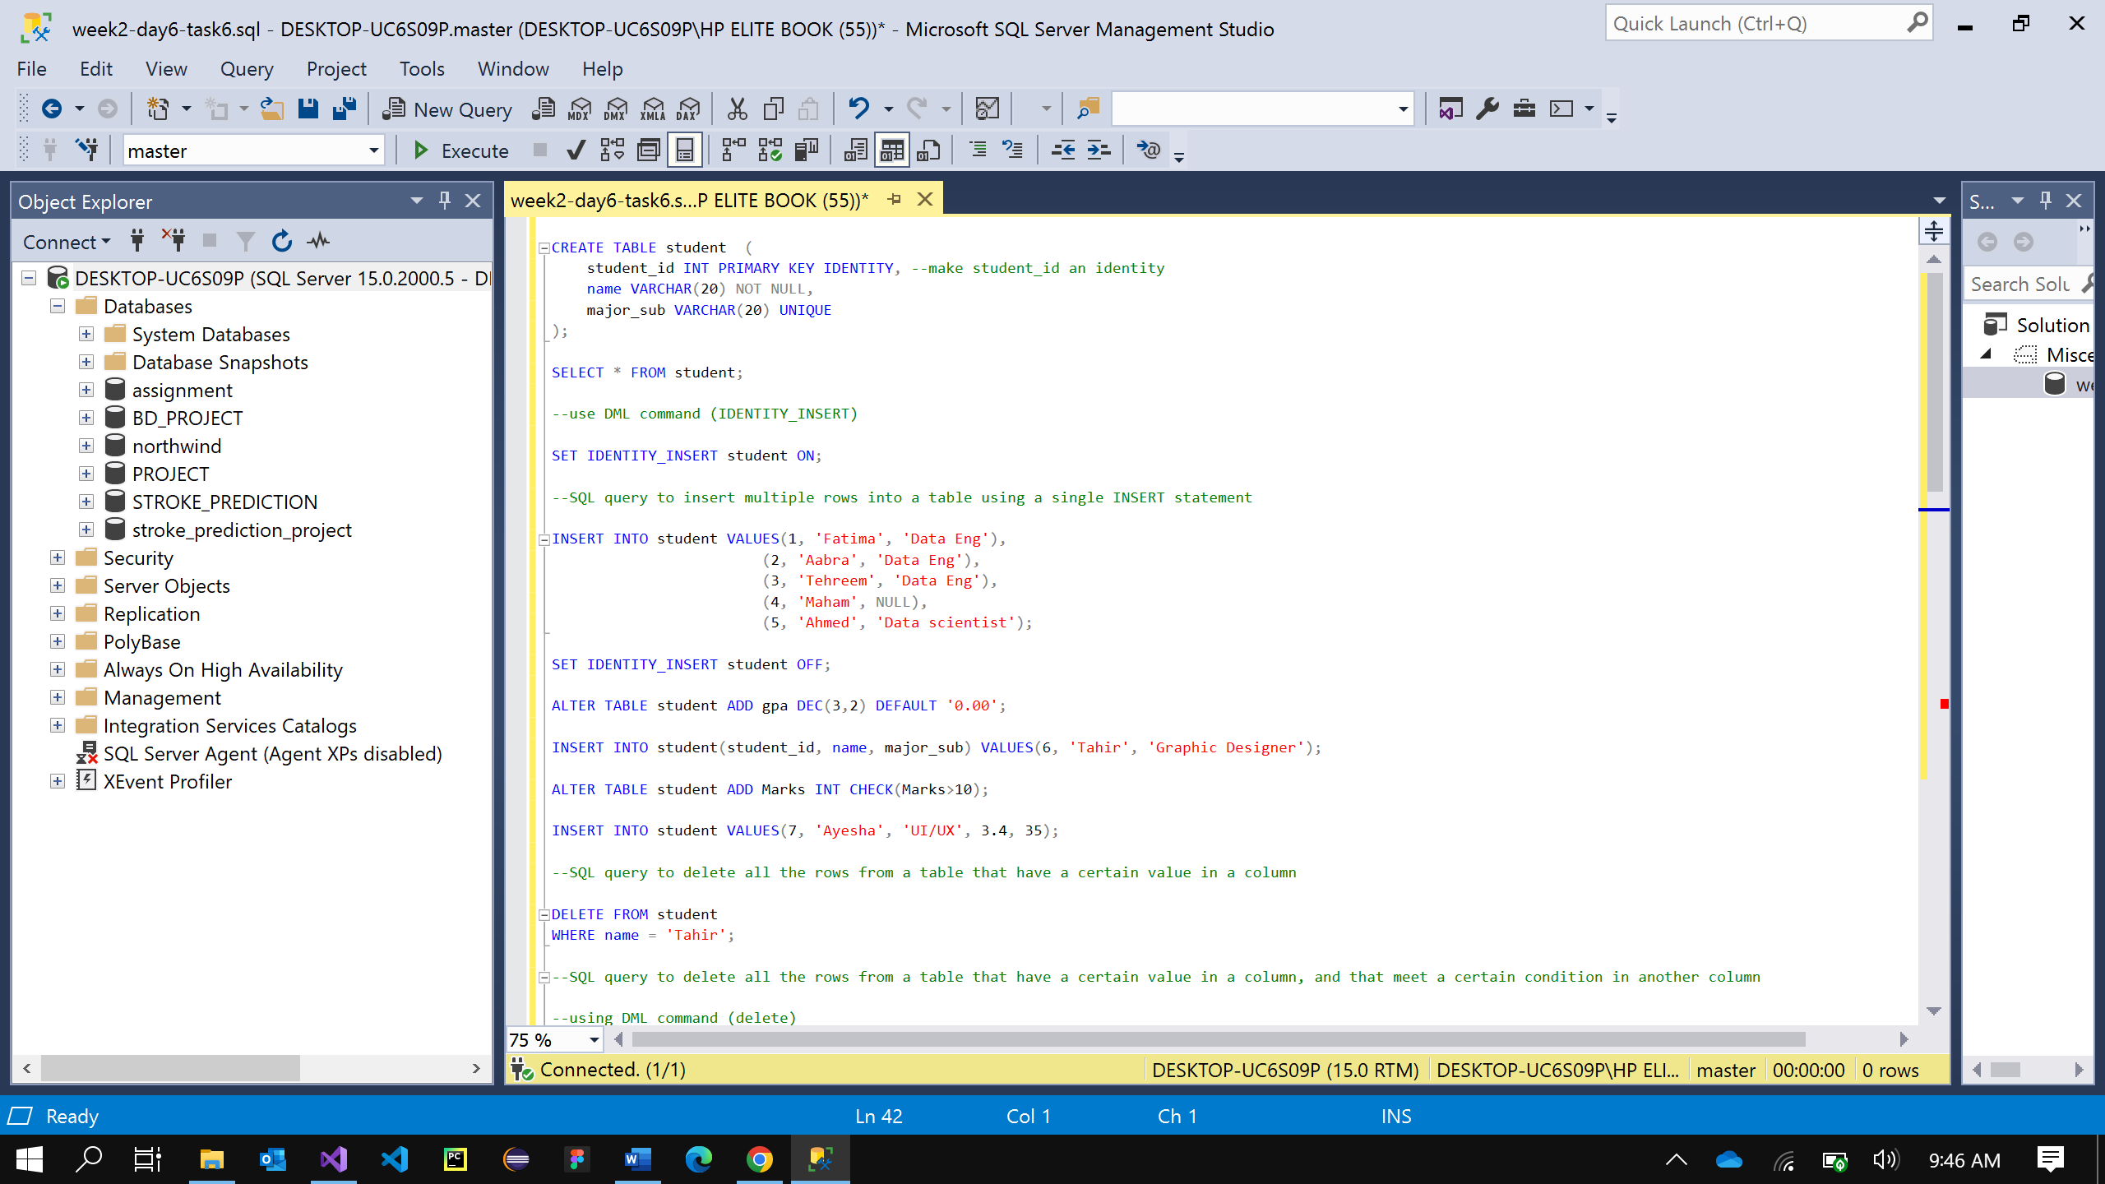

**2 - UPDATE**

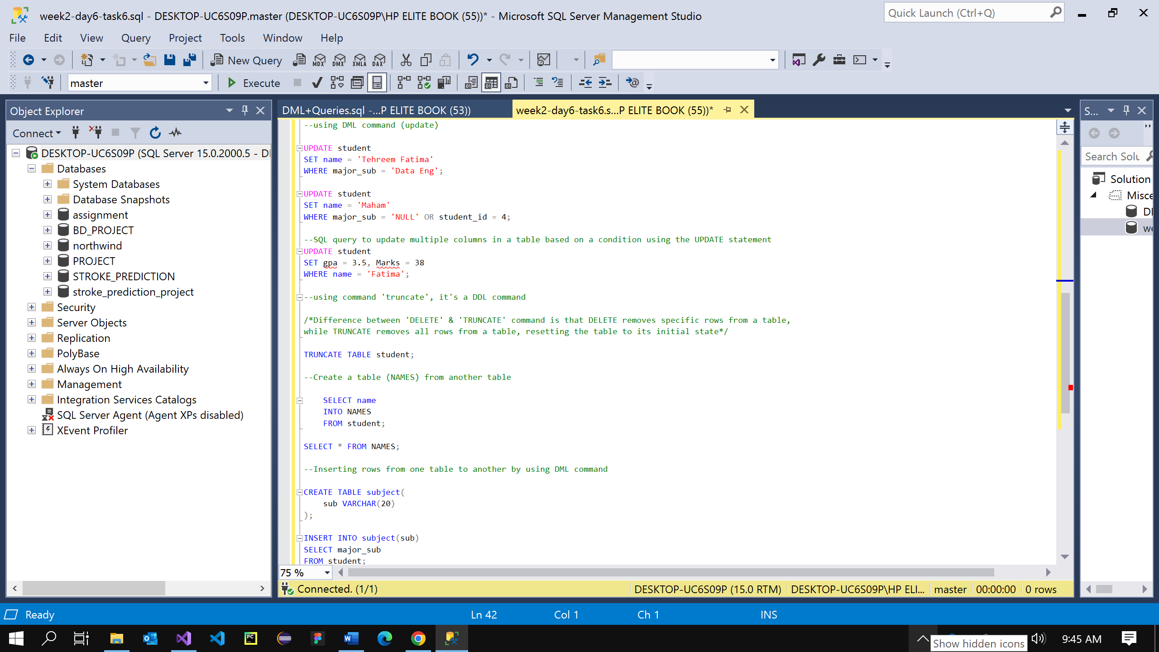

**3 - DELETE:**

**• Truncate**

**• Difference between delete & truncate**

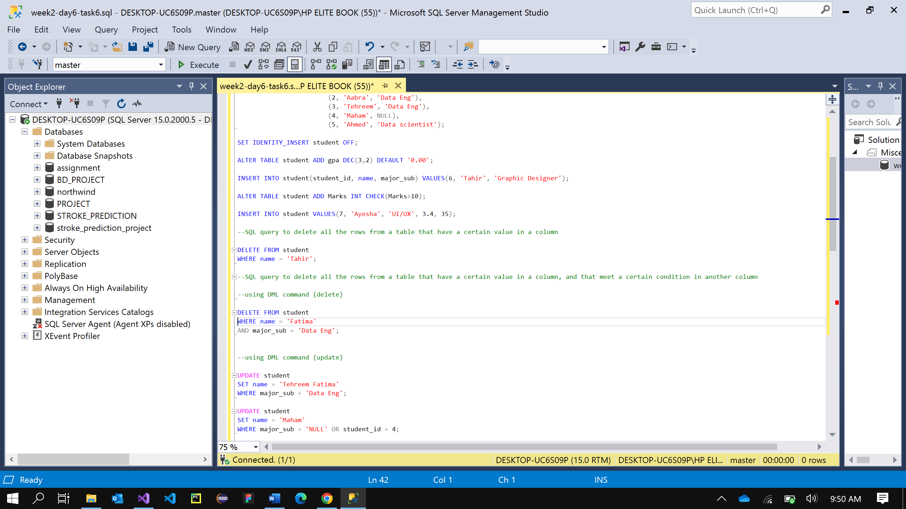

***Task # 8:***

**Write the following queries:**

**1 - Write an SQL query to insert multiple rows into a table using a single INSERT statement.**



**2 - Write an SQL query to delete all the rows from a table that have a certain value in a column.**

**3 - Write an SQL query to delete all the rows from a table that have a certain value in a column, and that meet a certain condition in another column.**



**4 - Write an SQL query to update multiple columns in a table based on a condition using the UPDATE statement.**

